(QUESTIONS 1-4)
Choose the best words to fill in the blanks.
1. January is the ___________ month of the year.

A first
B second
C third

2. I want to draw a line. Please lend me your ________.
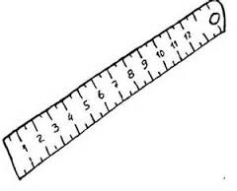
A eraser
B ruler
C pencil

3. I must save water. I must wash the vegetables in a ________ of water.
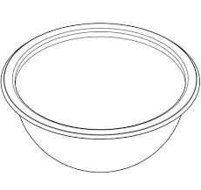
A bottle
B basin
C pail
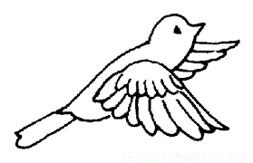
4. I am a bird. I have ___________.
A wings
B hump
C horns
(QUESTIONS 5-7)
Study the pictures carefully and choose the best phrases to complete the paragraph.
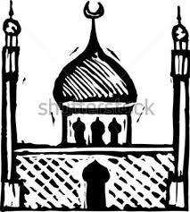
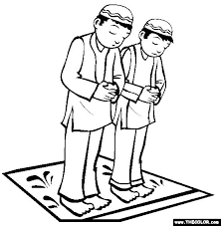

Amin goes to (5)_____________ every Friday.
He does his prayers there. He usually goes there (6)__________.
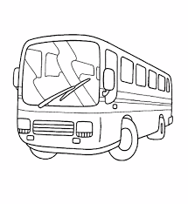
After that, they go home (7)____________.

5. A the church
B the mosque

6 A with his brother
B with his sister

7 A by bus
B by car

(QUESTIONS 8-10)
Study the pictures carefully. Then choose the best answers.
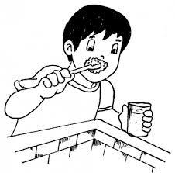
8. A Agus is brushing his teeth.
B Agus is washing his face.

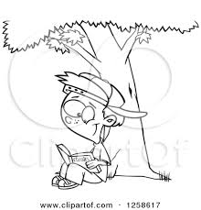
9. A Kevin is eating by the tree.
B Kevin is reading under a tree.

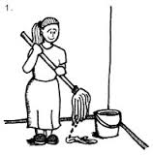
10. A Pat is mopping the floor
B Pat is sweeping the floor.

(QUESTIONS 11-15)
Look at the pictures below carefully. Choose the best sentence to fit the situation shown in the pictures.
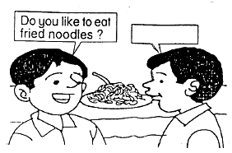
11. A Yes, I like to eat noodles.
B I bought it just now.

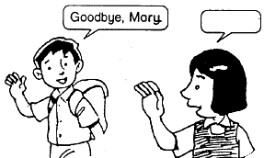
12. A Thank you, Sutip.
B See you tomorrow, Sutip.
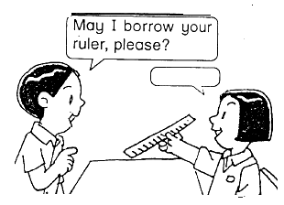
13. A Yes, you may, Aiman.
B Where is yours?

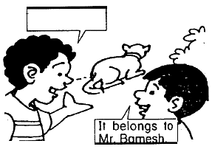
14. A Whose dog is that?
B Is it fierce?

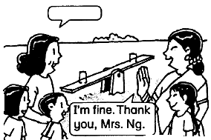
15. A Nice to meet you, Mrs Raj.
B How are you, Mrs Raj?

(QUESTIONS 16-21)
Choose the best answer to complete the sentence.
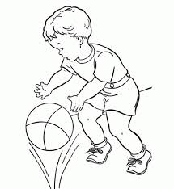
16. Irvin is a __________ boy.
A little
B fat

17. Pat and Tania are ________ friends.
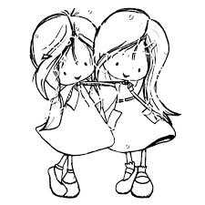
A bad
B good

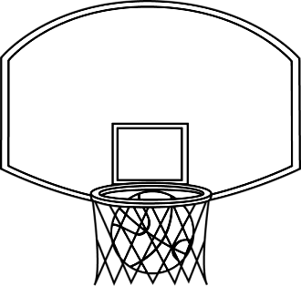
18. The ball is in the __________.

A box
B basket

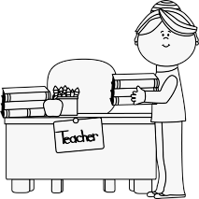
19. Put the book _______ the table.
A in
B on

20. Amir ______ Malek are good friends.
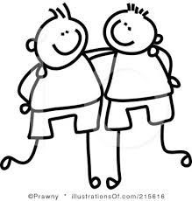
A and
B so

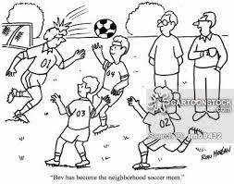
21. Alvin, Raju and Osman are playing football.
________ are in the field.
A You
B They

QUESTIONS 26-30
Choose the sentence with the correct punctuation.
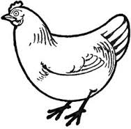
22. A What does a chicken gives us?
B what does a chicken gives us
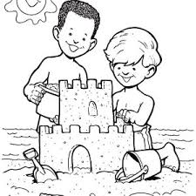
23. A pete and mike are on the beach
B Pete and Mike are on the beach.

QUESTIONS 24-30
Based on the picture, Choose the correct spelling.
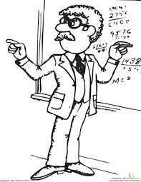
24. My father is a __________.
A ticer
B teacher
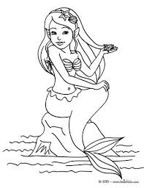
25. The ___________ lives in the sea.
A mermaid
B memek

26. A bloues
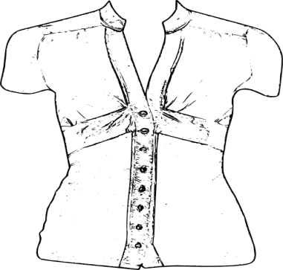
B blouse

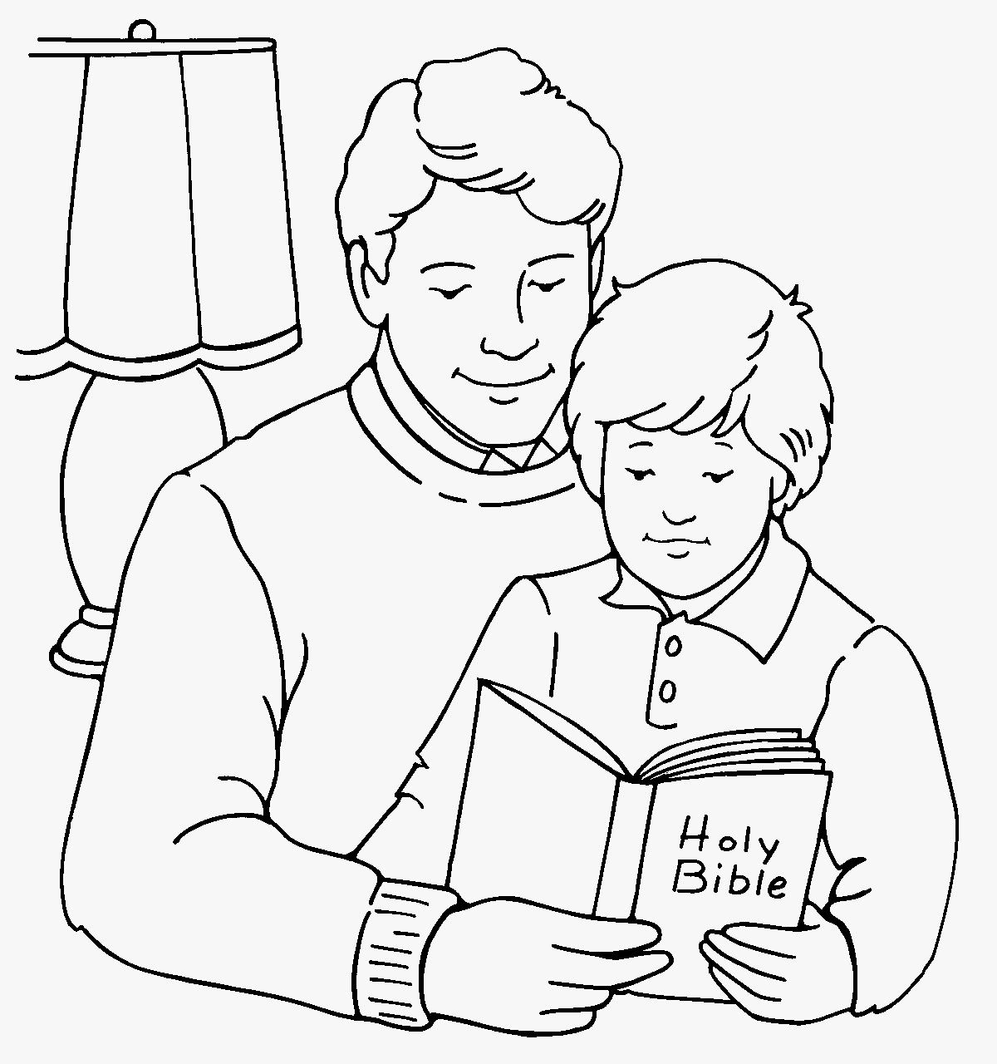
27. A reading
B riding

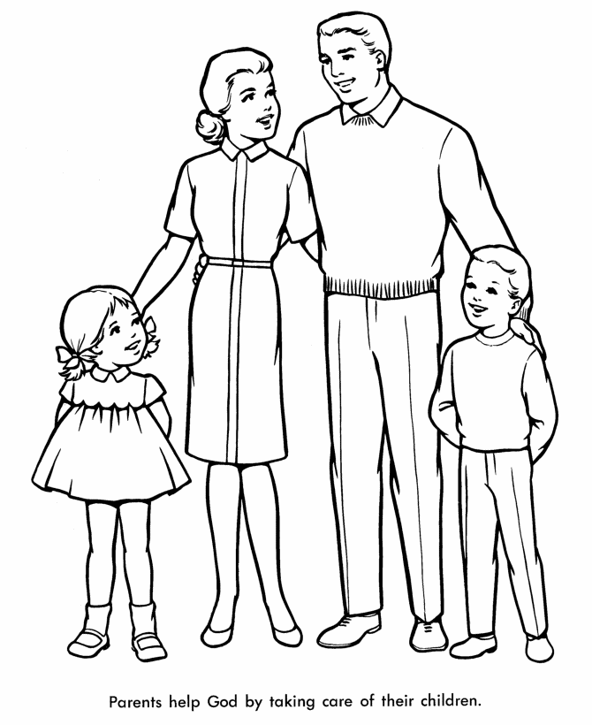

28. A famliy
B family
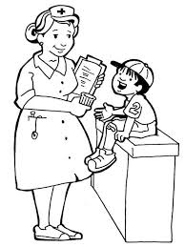
29. A nurse
B ners

30. A gaot
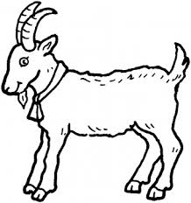

B goat

QUESTIONS 31-34
Choose the correct answer.
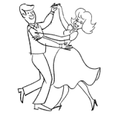
31. A singing
B dancing
C cycling

32. A collecting stamps
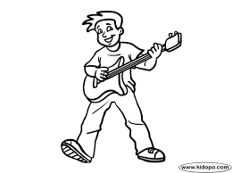
B listening to music
C playing guitar

33. A fishing
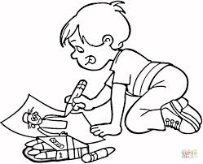
B reading
C drawing
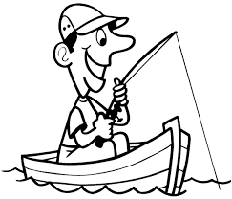
34. A cycling
B fishing
C swimming

QUESTIONS 35-40
Read the passage carefully. Based on the passage, choose the best answer to fill in the blanks.
Last week, Ali and his family went for a picnic. They went to Damai Beach. They went there by car. They left their home very early in the morning. It took them about two hours to reach their destination. When they arrived, Ali and his brother ran to the sea to swim. After swimming for three hours, Ali and his family had lunch which was prepared by his mother. Ali felt tired but very happy that day.

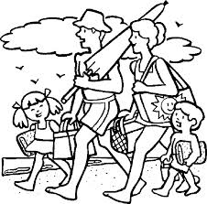
35. What did Ali do last week?
Ali and his family went for a _________.
A movie
B picnic

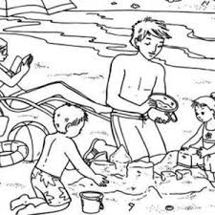
36. Where did they go?
They went to _____________.
A Damai Beach.
B school.

37. When did they go there?
They went very early in the ____________.
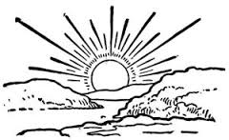
A morning.
B night.

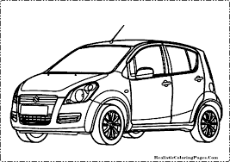
38. How did they go there?
They went there by a _________.
A car.
B bus.
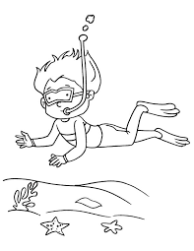
39. Where did Ali swim?
He swim in the __________.
A pond
B sea

40. How did Ali feel that day?
A angry
B happy

QUESTIONS 41-45
Read the passage carefully. Based on the passage, answer the questions.
Tania is in Year 2 Bestari. She has many new friends. Her friends are Mala, Sharmin and Sham. They always eat together during recess. Mala and Sharmin like to eat roti canai. Tania and Sham like fried noodles. In the evening, they go to the playground. They play on the swings and the sea-saw. Sometimes, they ride their bicycles. Dania enjoys playing with her friends.

41. Who are Tania’s friends ?
They are __________________________________________________.

42. What class are they in ?
They are in ________________________________________________.
43. What do Mala and Sharmin like to eat ?
They like to eat _____________________________________________.
44. Where do Tania and her friends like to go in the evening ?
In the evening, they like to go to ____________________________.
45. What do they like to play ?
They like to play ____________________________________________.

QUESTIONS 45-50
Read the passage carefully. Based on the passage, answer the questions.
Turtles are reptiles. They are cold-blooded animals. They have a hard shell covering their bodies. The shell may be rounded or flat. They can be in the colour of mud, green, or brown. Turtles live in the deep ocean. They have flippers which help them to swim. They do not give birth to their youngs but they lay eggs. During the egg-laying season, the female turtles crawl up to the beach to dig a hole to lay their eggs in it. After that, they cover the hole before returning to the ocean. Some of the well-known turtles are the leatherback turtles, the green turtles and the hawksbill turtles.

46. Turtles are ________________________.
47. In the passage, the word it refer to ( youngs , hole , ocean ).
48. Where do turtles live ?
The turtles live ___________________________________________.
49. What are the colours of the turtles ?
The turtles can be in _____________________________________.
50. Name a type of turtle that you know.
________________________________________________________
________________________________________________________

